Dynamic Music Playlist Management System Using Doubly Linked List

Introduction
The Dynamic Music Playlist Management System Using Doubly Linked List is a C++ project designed to manage songs in a playlist efficiently. It uses a doubly linked list, in which each node stores song information and two pointers that connect it to the previous and next songs. This structure allows dynamic insertion and deletion of songs without requiring a fixed amount of memory.
The system provides various operations, such as adding a song, deleting a song, searching for a song, displaying the playlist, playing the next song, and playing the previous song. It uses important data structure concepts, including pointers, dynamic memory allocation, and linked list operations. This project demonstrates how a doubly linked list can be applied to real-world music playlist management.

Problem Statement
To design and develop a Dynamic Music Playlist Management System using C++ and a Doubly Linked List to overcome the limitations of basic playlist management. The system aims to provide flexible song organization by allowing users to add new tracks, remove existing songs, search for specific tracks, and display the entire playlist. It also supports forward and backward navigation between songs through bidirectional links. Dynamic memory allocation is used to manage playlist size according to user requirements. The proposed system provides an organized, menu-driven interface and demonstrates how linked-list operations can improve the flexibility and efficiency of music playlist Management.
Algorithm:
1. Start the program.
2. Initialize an empty doubly linked list to store song details.
3. Display the menu containing options to add, delete, search, display, play the next song, play the previous song, and exit.
4. Accept the user's choice.
5. Perform the selected operation:
- **Add Song:** Enter the song name and artist name, create a new node, and insert it into the playlist.
- **Delete Song:** Enter the song name, search for it, and delete the corresponding node if found.
- **Search Song:** Search the playlist for the specified song and display its details if available.
- **Display Playlist:** Traverse the linked list and display all songs.
- **Play Next Song:** Move to the next song using the next pointer, if available.
- **Play Previous Song:** Move to the previous song using the previous pointer, if available.
6. If the selected operation is invalid, display an appropriate error message.
7. Return to the menu and accept another choice.
8. If the user selects Exit, release the dynamically allocated memory used by the playlist.
9. Stop the program.
Flowchart:

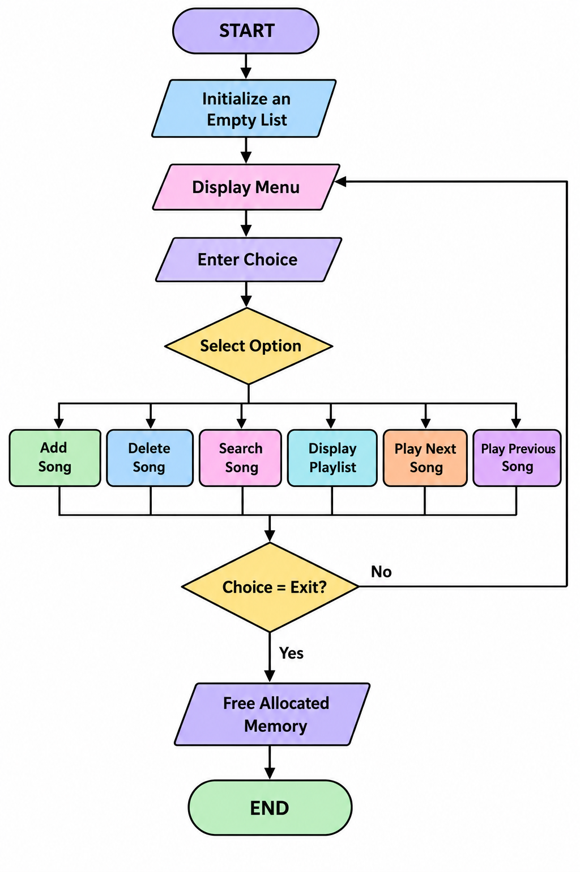
Conclusion:
The Dynamic Music Playlist Management System Using Doubly Linked List successfully demonstrates the application of data structures in managing a music playlist. It enables users to add, delete, search, and display songs dynamically, as well as navigate forward and backward through the playlist.
The project improves understanding of doubly linked lists, pointers, and dynamic memory allocation in C++. It provides a flexible and efficient approach to playlist management without requiring a fixed storage size. In the future, additional features such as shuffle play, repeat mode, song duration, and actual audio playback can be incorporated to make the system more advanced and user-friendly.

